**[Image Arithmetic in MATLAB with example](http://angeljohnsy.blogspot.com/2011/05/image-arithmetic.html)**

Image Arithmetic

    An image is represented in a matrix format.

    To perform image arithmetic the size of the two matrices should be same.

    The operation on two images results in a new image.

    Consider two images A and B with same size.

Image Addition

    In a RGB image, the addition of two images can be done using the ‘+’ operator. C=A+B;

Here, the minimum value of A+B and 255 is taken.

(i.e) C(i,j,1)=min(A(i,j,1)+B(i,j,1),255) where (i,j) represents the pixel position.

Image addition can be used to add the components from one image into other image.

Image Subtraction

A new image is obtained as a result of the difference between the pixels in the same location of the two images being subtracted.

C=A-B; ie. Maximum value of A-B and zero.

C(i,j,:) =max(A(i,j,:)-B(i,j,:),0).

Image subtraction is widely used for change detection.

For detecting the missing components in product assembly,

Example:To detect the defects in the [PCB.](http://www.amazon.com/Real-World-Springer-International-Engineering-Computer/dp/1402071302?ie=UTF8&tag=m089e-20&link_code=btl&camp=213689&creative=392969)

[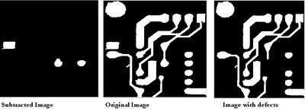](http://4.bp.blogspot.com/-va1pwdQDal4/TdFEI4Cer8I/AAAAAAAAALc/ji1m5SSWIZo/s1600/imsub.bmp)

Image subtraction is most beneficial in the area of medical image processing called mask mode radiography.

Image Multiplication

Image multiplication is used to increase the average gray level of the image by multiplying with a constant.

It is used for masking operations.

C=A.*B;

Image Division

Image division can be considered as multiplication of one image and the reciprocal of other image.

C=A.\B;

Logical Operations:

Logical operations are done on pixel by pixel basis.

The AND and OR operations are used for selecting subimages in an image .

This masking operation is referred as Region Of Interest processing.

Logical AND

To isolate the interested region from rest of the image portion logical AND or OR is used. Consider a mask image L for the image A.

To obtain the interested area, D= and(L,A) ;

We can use L&A also.

The resulting image will be stored in D which contains the isolated image part.

Logical OR

Syntax: D=or(L,A). We can also use L|A

background=imread('back.jpg');

A=imread('tommy1.bmp');

B=imread('jerry1.bmp');

%Image addition

%Both A and B are of same size

object=A+B;

[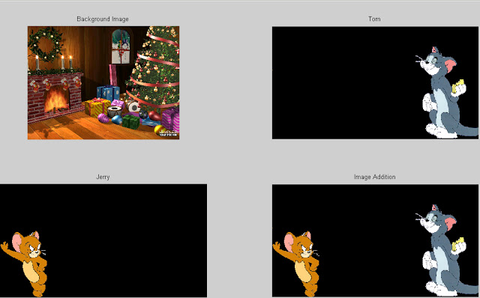](http://4.bp.blogspot.com/-t3YzfDWNKVI/TdFA1OiJ6jI/AAAAAAAAALQ/jaiv3ETF2XQ/s1600/arithmetic.bmp)

background=imresize(background,[size(object,1) size(object,2)]);

Im3=uint8(zeros(size(object)));

whiteImg=uint8(ones(size(object)));

%Array right division. A./B is the matrix with elements A(i,j)/B(i,j). Aand B must

%have the same size, unless one of them is a scalar.

%Image Division

mask=whiteImg./object;  
%Logical AND

im3=uint8(mask&background);%uint8(and(mask,background));

figure,imshow(mask);

%Array multiplication. A.*B is the element-by-element product of the arrays A and B.

%Image multiplication

%Multiply the background and the mask image

%And the result with the foreground image to obtain the final Image.

finalImg=(background.*im3)+object;

figure,imshow(finalImg);

[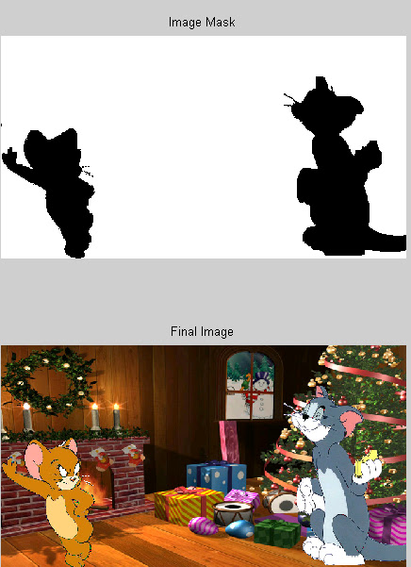](http://4.bp.blogspot.com/-0oPjwbwFIe4/TdFBsVPTlII/AAAAAAAAALY/Gym504DNuYw/s1600/arithmetic1.bmp)

[MATLAB Programming for Engineers](http://www.amazon.com/MATLAB-Programming-Engineers-Stephen-Chapman/dp/049524449X?ie=UTF8&tag=m089e-20&link_code=btl&camp=213689&creative=392969)

Example:2

|  |
| --- |
| [http://4.bp.blogspot.com/-o-xbGxFONUw/TqIwj1NC4wI/AAAAAAAAAY8/cDK8A4XF914/s320/img61.jpg](http://4.bp.blogspot.com/-o-xbGxFONUw/TqIwj1NC4wI/AAAAAAAAAY8/cDK8A4XF914/s1600/img61.jpg) |
| img61.jpg |

|  |
| --- |
| [http://3.bp.blogspot.com/-WjtXrOZwvQY/TqIwmfpRT_I/AAAAAAAAAZE/7lMtD2LwK70/s320/Sample_Image.jpg](http://3.bp.blogspot.com/-WjtXrOZwvQY/TqIwmfpRT_I/AAAAAAAAAZE/7lMtD2LwK70/s1600/Sample_Image.jpg) |
| Sample_Image.jpg |

D=imread('img61.jpg');

E=imread('Sample_Image.jpg');

 D=imresize(D,[size(E,1) size(E,2)]);

 A=double(E);

 C=uint8(zeros(size(A)));

 F=E;

 [x,y]=find((A(:,:,1)+A(:,:,2)+A(:,:,3))>650);

 for i=1:size(x,1)

    C(x(i),y(i),:)=1;

    F(x(i),y(i),:)=0;

 end

 C=C.*D;

  C=C+F;

  imshow(C);

[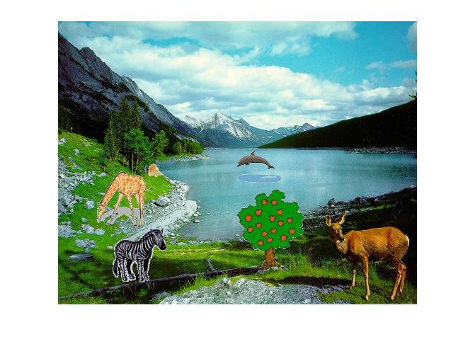](http://3.bp.blogspot.com/-pa5t6xS5nPo/TqIwnKSiY3I/AAAAAAAAAZM/d0SO1Lal3-Y/s1600/img_add.jpg)